‘;

Help feed our neighbors!

ORGANIZATION NAME
Food Drive
Month Day, 2016
Donation location: LOCATION
Time: X – X

Supporting the
Bountiful Community Food Pantry
www.bountifulfoodpantry.org
801.299.8464

Cash donations are also welcome
Please make checks payable to
Bountiful Community Food Pantry
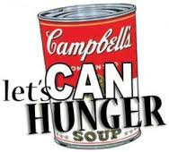

Thank you!!

Let’s CAN Hunger
in
Our Neighborhood!!!

ORGANIZATION NAME
Food Drive
Month Day, 2016
Donation location: LOCATION
Time: X – X

Supporting the
Bountiful Community Food Pantry
www.bountifulfoodpantry.org
801.299.8464

Cash donations are also welcome
Please make checks payable to
Bountiful Community Food Pantry

Thank you!!
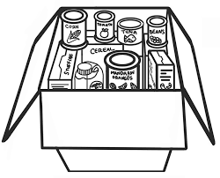

Additional clip art suggestions

